Default Route

🧱 What Is Default Route?
# Source: Chatgpt (GPT‑5 Mini) at [12/14/2025]
A default route is a special type of route used when a more specific route to a destination does not exist in the routing table. It tells a router or host,
“If you don’t know where to send the packet, send it here.”

🧠 Simple Definition:
# Source: Chatgpt (GPT‑5 Mini) at [12/14/2025]
A default route is a catch-all route that matches any destination not explicitly listed in the routing table.

📦 Default Route Format
# Source: Chatgpt (GPT‑5 Mini) at [12/14/2025]
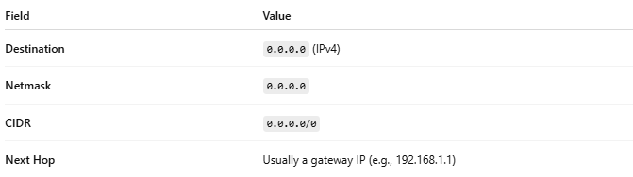
Field | Value
Destination | 0.0.0.0 (IPv4)
Netmask | 0.0.0.0
CIDR | 0.0.0.0/0
Next Hop | Usually a gateway IP (e.g., 192.168.1.1)
📘 For IPv6, it's written as:

::/0

🧾 Example: Default Route Entry
# Source: Chatgpt (GPT‑5 Mini) at [12/14/2025]
Destination | Subnet Mask | Next Hop | Interface | Type
0.0.0.0 | 0.0.0.0 | 192.168.1.1 | eth0 | Static or Dynamic
🟢 Meaning:
“Send any traffic not matching another route to 192.168.1.1 via eth0.”

📥 Common Use Cases
# Source: Chatgpt (GPT‑5 Mini) at [12/14/2025]
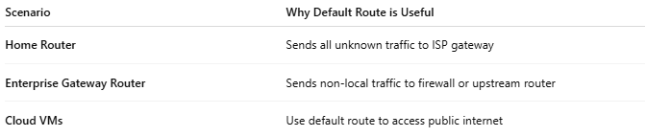

Scenario | Why Default Route is Useful
Home Router | Sends all unknown traffic to ISP gateway
Enterprise Gateway Router | Sends non-local traffic to firewall or upstream router
Cloud VMs | Use default route to access public internet

🔧 How to Set a Default Route

🖥 Linux CLI:
# Source: Chatgpt (GPT‑5 Mini) at [12/14/2025]
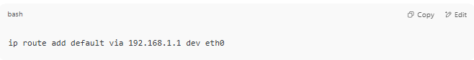
ip route add default via 192.168.1.1 dev eth0

🖥 Cisco IOS:
# Source: Chatgpt (GPT‑5 Mini) at [12/14/2025]
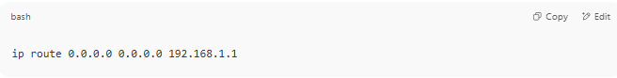
ip route 0.0.0.0 0.0.0.0 192.168.1.1

✅ Summary
# Source: Chatgpt (GPT‑5 Mini) at [12/14/2025]
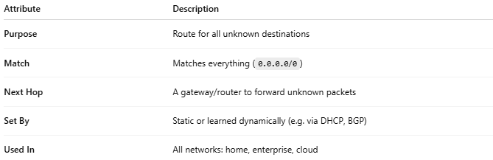
Attribute | Description
Purpose | Route for all unknown destinations
Match | Matches everything (0.0.0.0/0)
Next Hop | A gateway/router to forward unknown packets
Set By | Static or learned dynamically (e.g. via DHCP, BGP)
Used In | All networks: home, enterprise, cloud

